Dean Trust Rose Bridge

Teaching and Learning Policy

Version and Date |  | Action/Notes
1.0 | Feb 2020
2.0 | March 2021
3.0
4.0

Policy Reviewed: | March 2021
Policy Review Frequency: | Annually
Next Review: | March 2022
Signature of Headteacher: | Signature of Chairman of Local Governing Body:  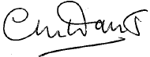

Vision and Aims:
At The Dean Trust, we believe that the acquisition of powerful knowledge and transferable skills, together with experiences that build social and cultural capital, is a fundamental right for all young people.
Our curriculum ambition, is to provide all our pupils with carefully crafted and sequenced knowledge enhancement and social development experiences, so that they are academically, socially and altruistically equipped to contribute positively to a global community. We have four core values, equally important and interconnected, that shape our curriculum. Our curriculum is designed so that all our pupils become;

- Powerfully Knowledgeable
- Global Citizens
- Healthy in Mind, Body and Soul
- Ambitious and Aspirational

The Dean Trust Teaching and Learning Policy is designed to be motivating, meaningful and manageable whilst developing a love of learning.

- Motivating – teaching and learning practices will help to inspire teachers and learners to possess a desire for continual self-improvement.
- Meaningful – evidence informed practices that advances pupils’ progress in their learning.
- Manageable – the policy eliminates any unnecessary workload and it encourages teachers to adjust their approach as necessary.
Rationale

We fully recognise that, by its complex nature, teaching and learning must take account of prior learning experiences alongside individual, cultural and contextual differences. Every pupil is entitled to a variety of learning experiences which inspires them to achieve their full potential. All staff have a responsibility, collectively and individually, to contribute to the delivery of the broad, challenging and appropriate curriculum. To be effective classroom practitioners all teachers should understand how learning occurs, and ensure that teaching and learning is of the highest quality.

Principles

- Pupils learn in an environment of respect and tolerance.
- Success is celebrated through a climate of praise and encouragement.
- Teachers support pupils to develop the dispositions to be successful learners.
- Pupils are given the opportunity and skills to clarify and communicate effectively.
- The curriculum helps pupils to understand, interpret and critique the world.
- Pupils are empowered to take risk without the fear of failure.
- Aspirational targets and evidence informed practice advances pupils’ progress.
- Home-learning is used to reinforce and extend what is learned in the classroom.
- High standards and expectations will challenge and engage all learners.
- Pupils are provided with feedback on their progress and precise guidance on how to improve.
- Teachers invest in their own professional development to acquire new knowledge and skills
- The core DTRB principles are displayed in all classrooms and sit at the centre of all we do (Appendix 1)

Teaching Practice

Effective teaching over time will invest in evidence-based practice: it may specify a commitment to, or draw upon, the practice below to enable pupils to make progress in their learning:
- Daily review
- New material in small steps
- Ask questions
- Provide models
- Guide pupil practice
- Check pupil understanding
- Obtain a high success rate
- Scaffolds difficult tasks
- Independent practice
- Frequent review
All of this is sequence in our DRTB Core Principles and 5 Phase Lesson structure (Appendix 2)

Teaching and Learning Protocols

The teaching and learning protocols reflect, a commitment from all teachers in the Dean Trust to undertake their responsibilities in a consistent manner. These are the foundations of our custom and practice, contributing to effective teaching and learning in our academies. These are specified in Appendix 3.

Improving the Quality of Teaching and Learning (IQTL)

There is a rigorous process of IQTL in each academy. This is based on regular and focused observations and work scrutiny, further supported by regular lesson drop-ins and pupil voice throughout the year. The IQTL process aims to achieve the following:

- Monitoring of the quality of teaching and learning.
- Providing feedback to teachers to improve the quality of teaching and learning.
- Using a non-judgement process to develop teachers and teaching.
- To create opportunities for reflective dialogue.
- Providing focused areas of strength and development.
- Encouraging self-reflection as a lever for improvement.
- Informing middle and senior leaders of priority areas.

There is a commitment to ensure that all teachers are given the opportunity to develop and share best practice. The annual academic calendar is designed to ensure that teaching and support staff engage in a cycle of monitoring, review and development. This is supported in two ways:

- Through a rigorous Performance Management/Appraisal schedule. As a result, staff set and review academic and personal teaching targets for themselves. These are closely linked to the school improvement plan (SIP) and complement the areas for pupil progress, teaching and learning and leadership and management.

- Through CPD. This is based on individual professional learning needs, whole school targets and national developments. They may consist of:
- Whole staff INSET sessions.
- Teaching and learning programmes.
- Teaching and learning forums.
- Research groups.
- Department development time.
In addition, these are supplemented by external courses and collaboration within The Dean Trust of schools, including Trust Improvement Partnerships (TIPs) and with other Teaching School Alliance partner schools.

Roles and Responsibilities

The Headteacher will ensure that:

- The policy and its procedures are followed.
- The teaching and learning policy is readily available and actively promoted.
- Teaching in school supports the vision and procedures outlined in the policy.
- Teaching in school addresses the emerging needs of pupils.
- Teaching in school supports the development of whole school priorities.
- Training in school supports the development of teachers.
- All staff understand their role in promoting effective teaching and learning and receive appropriate support through the aforementioned suite of training.

The Senior Lead for Teaching and Learning will ensure that:

- Teaching in school supports the vision and procedures outlined in the policy.
- Appropriate training is undertaken in order to support staff in carrying out their teaching responsibilities.
- Monitoring, evaluating and improving the quality of teaching and learning occurs across the academy.
- Reports are prepared for governors outlining the action taken within the preceding year, and evaluating the impact of that action; the annual report for governors will also outline recommendations for SIP targets for the following year.
- Staff and governors are kept up to date with relevant information relating to the quality of teaching and learning in the school.
- The effectiveness of the training has a positive and effective impact on teaching and learning and outcomes across the school.
- Staff are kept up to date on current research and evidence within teaching and education.

All staff will ensure that:

- They have read the policy and understand their responsibilities.
- They promote the core values outlined by the policy.
- They engage in performance management.
- They set teaching and learning targets in their Performance Management/Appraisal schedule and Departmental Self-Improvement Plan which meet their emerging needs.
- They engage in IQTL activities.
- They engage in Teaching and Learning training.
- They maintain a record of training attended.

Appendix I DTRB Core Principles

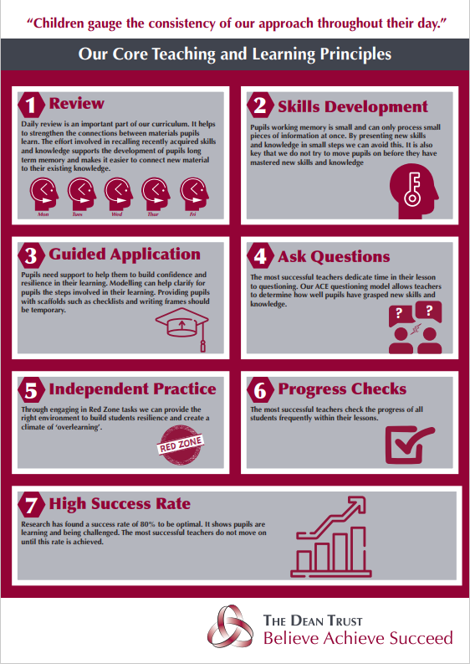

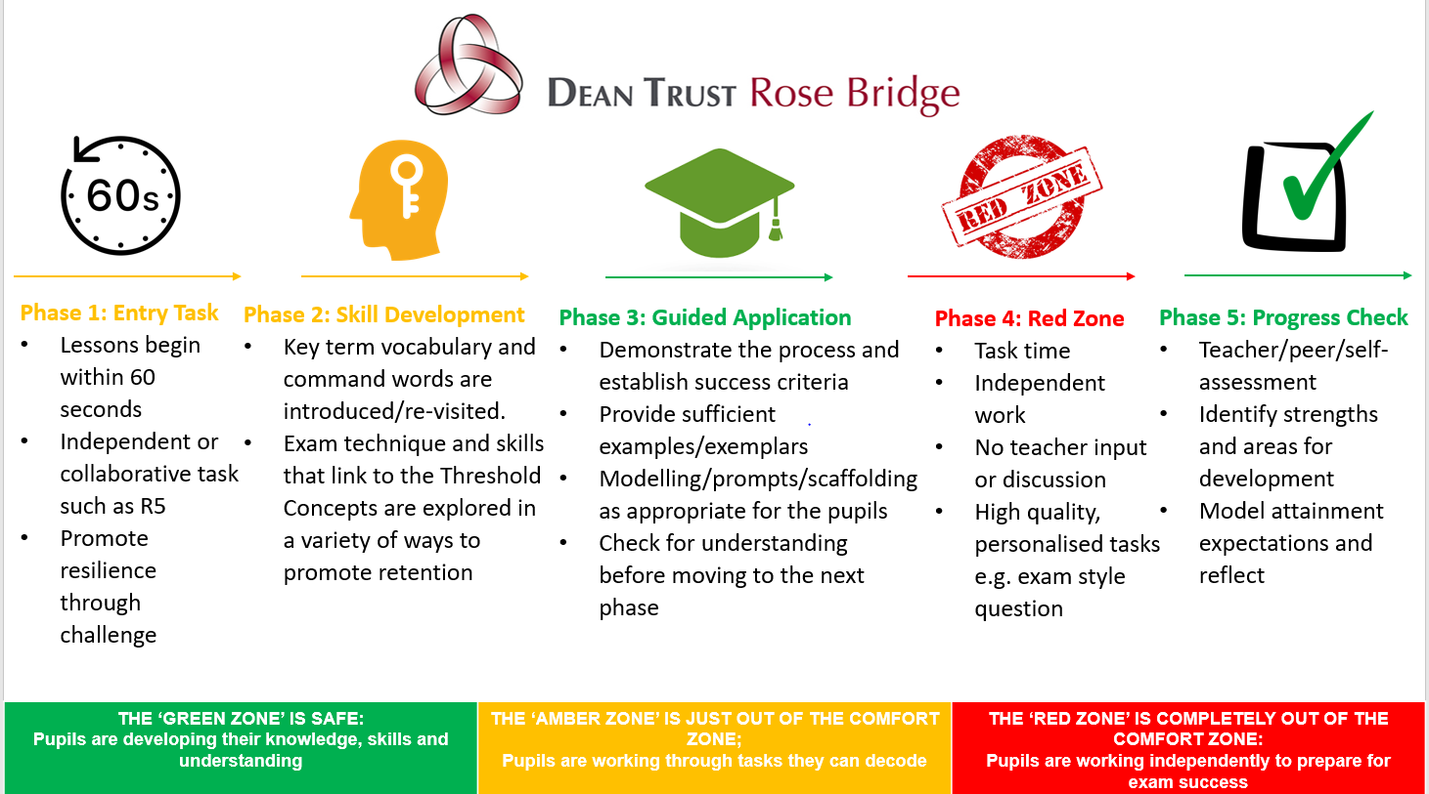
Appendix 2 Five Phase Lesson

Appendix 3 Teaching and Learning Protocols

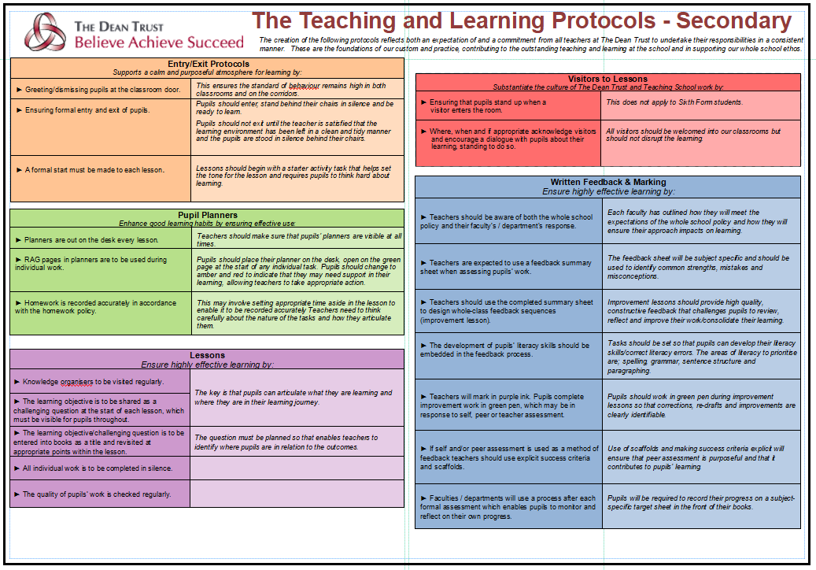

Appendix 4: Remote Learning

