Music KS3 Home Learning

Music Review  Listen to a piece of music of your choice. Describe any interesting features of the music. Would you recommend this to other listeners? Why/Why not? | DIY Instrument  Can you make a functioning instrument with items from around the house (check with the adult in your house before using them!)…can you then create a piece of music to perform using your new instrument? | Keyboard Practice  Draw a piano keyboard, label the notes and learn how to recognise where they are – it will be easier to play once we’re back in school.  If you have a keyboard at home then pick a piece of music and learn to play it fluently. | Song Lyrics  Take an existing song that you know well and re-write the lyrics to encourage people to follow the social distancing rules and/or wash their hands properly.
Musical Elements  Make a poster describing tempo, texture, dynamics, duration (rhythm), pitch and structure. Draw pictures to illustrate what each one means. | Jukebox  Jukeboxes were around from the 1950s, people would put coins in and select their favourite song to play. Make a list of your ten favourite songs and who sang them; give a musical reason why you like each one. Remember to use musical terminology. | Stomp Questions (use the text on the back)  1. Which art forms are combined in Stomp?  2. Where did it originate?  3. What is a busker?  4. What is an ostinato?  5. How do Stomp use rhythms in their music? | Rhythm Writer  Using the note length reminders on the back of this page, create a set of rhythms that would fit into a 4/4 time signature (each bar should add up to 4 beats), try and fit words to your rhythms to make them easier to perform. How many can you come up with?
Treble Clef Word Generator  Using the notes of the treble clef, how many different words can you create? Draw them out using the notes and label them underneath. Take care with where you place them. If there is more than one of a letter in the word can use different pitches? | Movie Critic  Listen to the theme tune of a film. Write a paragraph to describe how the musical elements are used in it. Can you explain what makes the theme tune fit the movie it is used for? | Instrument Info.  Draw a detailed picture of an instrument of your choice. Label the different parts of the instrument and describe how it works in order to create a sound. Can you describe how it makes different sounds? (sfs kids) | Popular Poster  Create a poster to be displayed in the Music classroom about your favourite band or artist. Justify why you enjoy their music and how you think they’ve helped shape the world of Music. Include pictures as well as text.
Rhythm Questions (text on the back)  1. What styles/genres of music do you think use polyrhythms and why?  2. Can you think of some songs or pieces of music that you know that you would describe as having a 2, 3 or 4 beat pulse? | Stage Manager  Create a birds-eye stage plan for a performance by your favourite band. Think about where equipment such as mics, amps and speakers would be placed as well as additional items such as pyrotechnics and moving stage items. | Family and Friend Playlist  Ask at least five other people (phone/text is fine) to tell you some of their favourite songs, who sings them and why they like them. Make a playlist of your favourite songs from the list. | Compare and Contrast  Listen to two pieces of music which are in different genres. Describe how the musical elements are used in each piece and then write a paragraph to show why they could not be classed as the same genre.
Listen In  Listen to a piece of music that you do not like. Write a paragraph to describe what the music sounds like – do not include your opinion, just state the facts. Justify what it is you do not like about it, has your opinion changed? | Treble Clef Story  Write a short story but use notes of the treble clef for any of the words you created on the treble clef generator. You will need to write it by hand and draw the stave with a ruler to show the words clearly. | Film Music Composer  Draw a storyboard of a film (at least 6 frames) and describe how you would expect the instrumentation, tempo and pitch to sound for each of the scenes. Try to be as detailed as possible, think about how it may change in each frame. | Stomp Performance  Create your own piece of ‘stomp’ music. Think about how you can create different sounds using general items (i.e. yard brush) and body percussion and how you could layer these to create an interesting performance.

Pulse and Rhythm Text  The word rhythm comes from the Greek ‘rhythmos’ which describes any recurring motion that is marked by strong and weak elements. We use the word to describe the ways notes are grouped together in terms of duration (how long they are) as well as how they are accented (an accent gives a single note extra importance in a phrase.)  In performance arts, rhythm describes how things are timed such as the steps of a dance or the meter of spoken language in poetry. In musical forms such as Hip-Hop, the rhythmic delivery of the lyrics is one of the most important elements of the style.  Some of the beats in a piece of music have more importance than others, these are usually the notes that are given ‘accents,’ they let us hear the notes in groups of equal units which are called bars. The bars are usually grouped in to either 2, 3 or 4 beats with the first beat of each bar usually feeling ‘accented’ – that is the note you would tap your foot along to while listening to the music. The picture below shows how the different groupings work if you stress the capital letters on the right hand side while saying the rhythms. Rhythms can be used on their own but they are usually combined with other rhythms over a pulse (steady beat). If the rhythms are very different but played at the same time it is called a Polyrhythm.  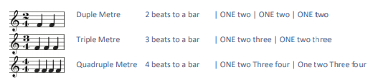 | Stomp Text  STOMP is a percussion group, originating in Brighton, United Kingdom. They use the body and ordinary objects to create physical theatre performances using rhythms, acrobatics, dance and pantomime; there is no talking or singing involved. The group was created in 1991 by Steve McNicholas and Luke Cresswell who had been working as ‘buskers’ in a street band called Pookiesnackenburger.  The music that STOMP create involves weaving different rhythms together, they begin with a single rhythm and repeat it (this is called an ostinato) before layering different ostinato patterns over the top to add interest to their piece – this can make it very challenging to perform.  STOMP’s performances could be argued as not being ‘musical’ as they have no melodies to sing along with, however, the rhythms they create are a different type of music all by themselves. The group have performed at many venues and big events around the world and there are now several different STOMP ‘casts’ that perform mainly in the UK and America on the West End and Broadway. STOMP have even performed on Sesame Street alongside the Muppets, the Royal Variety Show and the closing ceremony of the 2012 Summer Olympics in London.
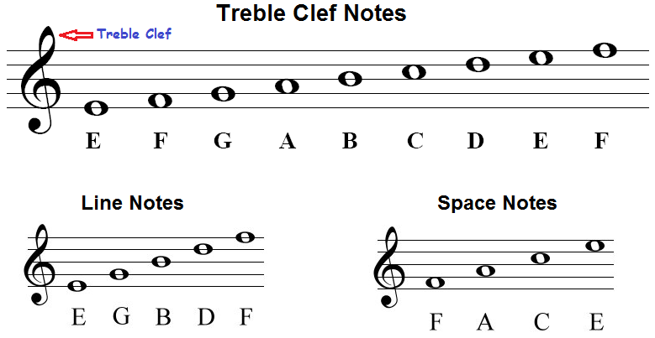 | Note Values  