OBSERVATIONAL DRAWING PROJECT
NATURAL FORMS

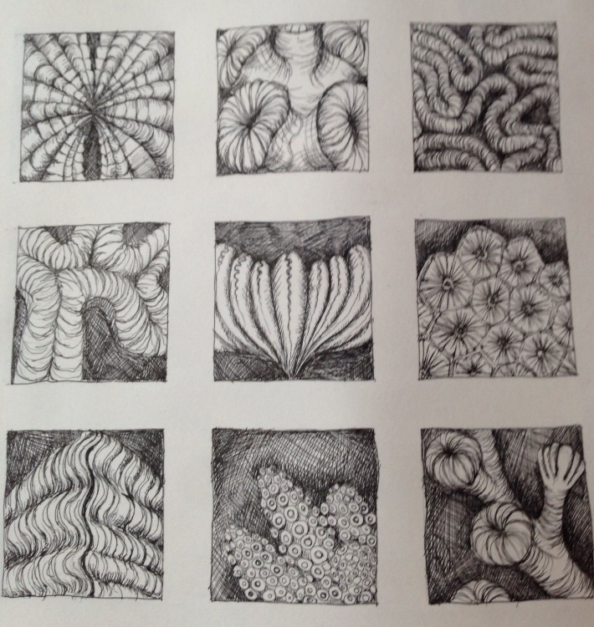
Pencil shade and tone Colour pencils or felt tip pens Fine line or biro pen

STEPS:
- Create nine equal squares with a ruler (or something with a straight edge) on an A4 sheet of paper.
- Choose from the different mediums above: Pencil, colour pencils, felt tip pens, fine liner or biro.
- When going outside for exercise or in your garden choose objects that are natural forms, e.g. a leaf, a flower, a pinecone. This can be one object or multiple different objects.
- Draw up close from different areas of your object, then try and draw the full object.
- Remember to use detail, proportion, accuracy and control.

BONUS: Faces in places-
- When you are outdoors look at your surroundings.
- Try to find a face in a natural place, for example: a tree, on the pavement.
- Take a picture on your phone or camera.
- Draw a line drawing in pencil or pen from the picture you have taken.

