Year 9 History
Work Booklet
African American Civil Rights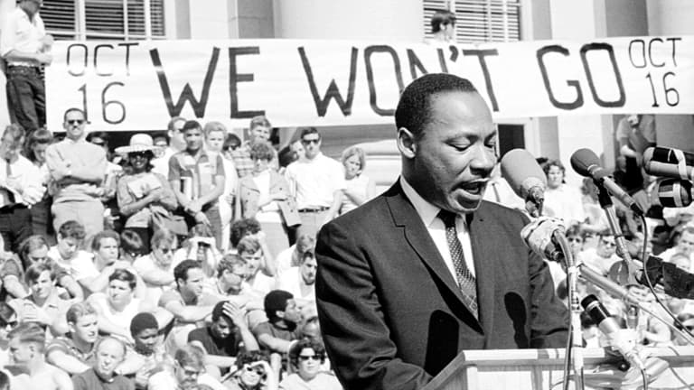

Name: _____________________________________
Class: _________________
Teacher: ___________________________________

- Rosa Parks and the Bus Boycott (Pages 30-31)

- Read the information on pages 30-31 highlighting any key points.
- What were the rules regarding segregation on buses?
……………………………………………………………………………………………………………………………………………………………………………………………………………………………………………………………………………………
…………………………………………………………………………………………………………………………………………
…………………………………………………………………………………………………………………………………………
- Describe what Rosa Parks did during her protest.
……………………………………………………………………………………………………………………………………………………………………………………………………………………………………………………………………………………………………………………………………………………………………………………………………………………………………………………………………………………………………………………………………………………………………………………………………………………………………………………………………………………………………………………………………………………………………………………………………………………………………………………………………………………………………………………………………………………………………………………………………………………………………………………………………………………………………………………………………………………
- What did the NAACP do in reaction to the arrest of Rosa Parks?
……………………………………………………………………………………………………………………………………………………………………………………………………………………………………………………………………………………………………………………………………………………………………………………………………………………………………………………………………………………………………………………………………………………………………………………………………………………………………………………………………………………………………………………………………………………………………………………………………………………………………………………………………………………………………………………………………………………………………………………………………………………………………………………………………………………………………………………………………………………
- What happened to Martin Luther King as a result of the Bus Boycott?
………………………………………………………………………………………………………………………………………………………………………………………………………………………………………………………………………………………………………………………………………………………………………………………………………………………………………………………………………………………………………………………………………………………………………………………………………………………………………………………………………………………………………………………………………………………………………………………………………………………………………………………………
6. Imagine that you were with Rosa Parks when she was arrested.
- Explain why she refused to move
- Describe how she was treated
- Describe how the boycott followed on from this event and how Martin Luther King became the leader of the Civil Rights movement
………………………………………………………………………………………………………………………………………………………………………………………………………………………………………………………………………………………………………………………………………………………………………………………………………………………………………………………………………………………………………………………………………………………………………………………………………………………………………………………………………………………………………………………………………………………………………………………………………………………………………………………………………………………………………………………………………………………………………………………………………………………………………………………………………………………………………………………………………………………………………………………………………………………………………………………………………………………………………………………………………………………………………………………………………………………………………………………………………………………………………………………………………………………………………………………………………………………………………………………………………………………………………………………………………………………………………………………………………………………………………………………………………………………………………………………………………………………………………………………………………………………………………………………………………………………………………………………………………………………………………………………………………………………………………………………………………………………………………………………………………………………………………………………………………………………………………………………………………………………………………………………………………………………………………………………………………………………………………………………………………………………………………………………………………………………………………………………………………………………………………………………………………………………………………………………………………………………………………………………………………………………………………………………………………………………………………………………………………………………………………………………………………………………………………………………………………………………………………………………………………………………………………………………………………………………………………………………………
2) How far did the ‘challengers’ succeed? (Pages34-35)
1. Read the information on pages34-35 highlighting any key points.
2. Describe the events of Little Rock in 1957.
………………………………………………………………………………………………………………………………………………………………………………………………………………………………………………………………………………………………………………………………………………………………………………………………………………………………………………………………………………………………………………………………………………………………………………………………………………………………………………………………………………………………………………………………………………………………………………………………………………………………………………………………………………………………………………………………………………………………………………………………………………………………………………………………………………………………………………………………………………………………………………………………
3. What happened at the lunch counter sit-ins?
………………………………………………………………………………………………………………………………………………………………………………………………………………………………………………………………………………………………………………………………………………………………………………………………………………………………………………………………………………………………………………………………………………………………………………………………………………………………………………………………………………………………………………………………………………………………………………………………………………………………………………………………………………………………………………………………………………………………………………………………………………………………………………………………………………………………………………………………………………………………………………………………
4. CMQ: Why do you think that the police were slow to react when a mob of whites attacked lunch counter protestors?
……………………………………………………………………………………………………………………………………………………………………………………………………………………………………………………………………………………………………………………………………………………………………………………………………………………………………………………………………………………………………………………………………………………………………………………………………………………………………………………………………………………………………………………………………………………………………………………………………………………………………………………………………………………………………………………………………………………………………………………………………………………………
5.Explain why CORE planned the ‘freedom riders’ tour of America. ………………………………………………………………………………………………………………………………………………………………………………………………………………………………………………………………………………………………………………………………………………………………………………………………………………………………………………………………………………………………………………………………………………………………………………………………………………………………………………………………………………………………………………………………………………………………………………………………………………………………………………………………………………………………………………………………………………………………………………………………………………………………………………
6. What happened to the freedom riders?
………………………………………………………………………………………………………………………………………………………………………………………………………………………………………………………………………………………………………………………………………………………………………………………………………………………………………………………………………………………………………………………………………………………………………………………………………………………………………………………………………………………………………………………………………………………………………………………………………………………………………………………………………………………………………………………………………………………………………………………………………………………………………………

2) How far did the ‘challengers’ succeed? (Pages36-37)
1. Use the information on pages 36-37 to complete the mind map. Remember you should summarise the key points
Voting Rights
Another step forward
Hearts and Minds
The Police
Politics
Challenges to Segregation

2. Study Source E on page 37. Why do you think this speech was a ‘turning point’ in the struggle for Black Civil Rights?
………………………………………………………………………………………………………………………………………………………………………………………………………………………………………………………………………………………………………………………………………………………………………………………………………………………………………………………………………………………………………………………………………………………………………………………………………………………………………………………………………………………………………………………………………………………………………………………………………………………………………………………………………………………………………………………………………………………………………………………………………………………………………………………………………………………………………………………………………………………………………………………………
3. imagine that you are a member of the Nobel Peace Prize selection panel. Write a report on the work of Martin Luther King explaining why he deserves the prize.
………………………………………………………………………………………………………………………………………………………………………………………………………………………………………………………………………………………………………………………………………………………………………………………………………………………………………………………………………………………………………………………………………………………………………………………………………………………………………………………………………………………………………………………………………………………………………………………………………………………………………………………………………………………………………………………………………………………………………………………………………………………………………………………………………………………………………………………………………………………………………………………………
………………………………………………………………………………………………………………………………………………………………………………………………………………………………………………………………………………………………………………………………………………………………………………………………………………………………………………………………………………………………………………………………………………………………………………………………………………………………………………………………………………………………………………………………………………………………………………………………………………………………………………………………………………………………………………………………………………………………………………………………………………………………………………………………………………………………………………………………………………………………………………………………
………………………………………………………………………………………………………………………………………………………………………………………………………………………………………………………………………………………………………………………………………………………………………………………………………………………………………………
2) From the 1960’s to the New Millennium (Pages40-41)
1. Name the militant groups set up to address civil rights in America.
………………………………………………………………………………………………………………………………………………………………………………………………………………………………………………………………………………………………
2. What did these militant groups do?
………………………………………………………………………………………………………………………………………………………………………………………………………………………………………………………………………………………………………………………………………………………………………………………………………………………………………………………………………………………………………………………………………………………………………………………………
3. CMQ: Why do you think some people turned away from Martin Luther King’s idea of non-violence? …………………………………………………………………………………………………………………………………………………………………………………………………………………………………………………………………………………………………………………………………………………………………………………………………………………………………………………………………………………………………………………………………………………………………………………………………………………………………………………………………………………………………………………………………………………………………………………………………………………………………………………………………………………………………………………………………………………………………………………………………………………………………………………………………………………………………………………………………………………………………………

4. Describe the events at the 1968 Olympics.
………………………………………………………………………………………………………………………………………………………………………………………………………………………………………………………………………………………………………………………………………………………………………………………………………………………………………………………………………………………………………………………………………………………………………………………………………………………………………………………………………………………………………………………………………………………………………………………………………………………………………………………………………………………………
- Why did Blacks realise that it was important for them to focus on getting a good education?
………………………………………………………………………………………………………………………………………………………………………………………………………………………………………………………………………………………………………………………………………………………………………………………………………………………………………………………………………………………………………………………………………………………………………………………………………………………………………………………………………………………………………………………………………………………………………………………………………………………………………………………………………………………………………………………………………………………………………………………………………………………………………………………………………………………………………………………………………………………………………………………………

