Year 7 History
Work Booklet
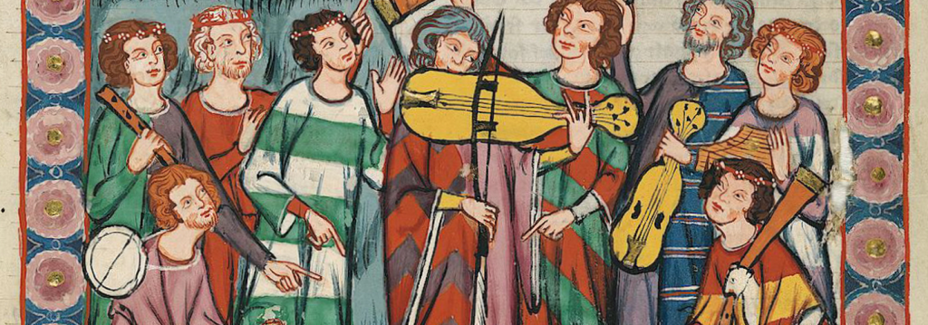
Life in Medieval England

Name: _____________________________________
Class: _________________
Teacher: ___________________________________

- Life in a Medieval Village (Page 80-81)

- Read the information on pages 80-81 highlighting any key points.
- Who owned most of the land in villages?
…………………………………………………………………………………………………………………………………………
- What is a villein?
…………………………………………………………………………………………………………………………………………
- What animals with medieval farmers keep?
…………………………………………………………………………………………………………………………………………
- Use the information on page 80 to complete the diagram below: (You should summarise the information)

How does this villager spend his day?

What do they eat?

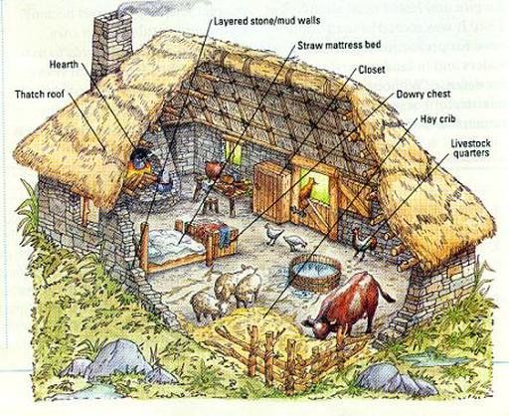
Where do they live?

Couldn’t the villeins just run away?

What about his wife?

- Make a list of the kinds of food people ate in the Middle Ages.

- Write down the ways in which these foods are different to your meals today.
…………………………………………………………………………………………………………………………………………
…………………………………………………………………………………………………………………………………………
…………………………………………………………………………………………………………………………………………
…………………………………………………………………………………………………………………………………………
- In your opinion, who has the healthier diet? Give reasons for your answer.
…………………………………………………………………………………………………………………………………………
…………………………………………………………………………………………………………………………………………
…………………………………………………………………………………………………………………………………………
……………………………………………………………………………………………………………………………………………………………………………………………………………………………………………………………………………………
…………………………………………………………………………………………………………………………………………
- CMQ: Why did most people in Medieval England spend most of their time in the same village?
………………………………………………………………………………………………………………………………
………………………………………………………………………………………………………………………………
………………………………………………………………………………………………………………………………
………………………………………………………………………………………………………………………………………………………………………………………………………………………………………………………………
………………………………………………………………………………………………………………………………………………………………………………………………………………………………………………………………
………………………………………………………………………………………………………………………………
………………………………………………………………………………………………………………………………

- Imagine that you are a villein living in a medieval village. Write a description of a day in your life. Try to include as much detail as possible.
Here are some ideas to think about:
- What time of year is it?
- How does your working day change throughout the year?
- What places will you work in or visit?
- What sort of people will you meet?
- Is there a particular type of food you enjoy?
- At what times do you eat?
………………………………………………………………………………………………………………………………………………………………………………………………………………………………………………………………………………………………………………………………………………………………………………………………………………………………………………………………………………………………………………………………………………………………………………………………………………………………………………………………………………………………………………………………………………………………………………………………………………………………………………………………………………………………………………………………………………………………………………………………………………………………………………………………………………………………………………………………………………………………………………………………………………………………………………………………………………………………………………………………………………………………………………………………………………………………………………………………………………………………………………………………………………………………………………………………………………………………………………………………………………………………………………………………………………………………………………………………………………………………………………………………………………………………………………………………………………………………………………………………………………………………………………………………………………………………………………………………………………………………………………………………………………………………………………………………………………………………………………………………………………………………………………………………………………………………………………………………………………………………………………………………………………………………………………………………………………………………………………………………………………………………………………………………………………………………………………………………………………………………………………………………………………………………………………………………………………………………………………………………………………………………………………………………………………………………………………………………………………………………………………………………………………………………………………………………………………………………………………………………………………………………………………………………………………………………………………………………………………………………………………………………………………………………………………………………

2) Life in a Medieval Town (Page 82-83)
1. Read the information on pages 82-83 highlighting any key points.
2. Explain the meanings of the following words:
population
charter
guild
crossroads
freedom

3. Find the correct numbers to the answer the questions below:
a) How many towns were there in England by 1066?
………………………………………………………………………………………………………………………………………………
b) How many people were living in London by 1066?
………………………………………………………………………………………………………………………………………………
c) What was the approximate number of people living in a small village in 1066?
………………………………………………………………………………………………………………………………………………
d) How many towns had received their charter of freedom by 1400?
………………………………………………………………………………………………………………………………………………
e) How many people were living in London by 1400?
………………………………………………………………………………………………………………………………………………

4. Why do you think so many towns were created near to a castle or a monastery?
………………………………………………………………………………………………………………………………………………………………………………………………………………………………………………………………………………………………………………………………………………………………………………………………………………………………………………………………………………………………………………………………………………………………………………………………………………………………………………………………………………………………………………………………………………………………………………………………………………………………………………………………………………………………………………………………………………………………………………………………………………………………………………
5. Imagine that you are a shop owner in a Medieval town. Design a sign for your shop in the space below: (Remember people couldn’t read so your sign must show what you are selling)

2) Could you have fun in the Middle Ages? (Page 84-85)
1. Read the information on pages 82-83 highlighting any key points.
2. Using the information complete the chart below about the different types of games/sporting activities played in Medieval England :
Game/Sport | Description
Conkers
Bowling
Golf
Football
Cold Hand
Cockerel fighting
Shin
Hacking
Ice Skating
Archery
Stoolball
Bear Baiting
Wrestling

3. Explain where the modern word ‘holiday’ comes from.
………………………………………………………………………………………………………………………………………………………………………………………………………………………………………………………………………………………………………………………………………………………………………………………………………………………………………………………………………………………………………………………………………………………………………………………………

CMQ: Explain how activities for the rich were different from those of the poor.
……………………………………………………………………………………………………………………………………………………………………………………………………………………………………………………………………………………………………………………………………………………………………………………………………………………………………………………………………………………………………………………………………………………………………………………………………………………………………………………………………………………………………………………………………………………………………………………………………………………………………………………………………………………………………………………………………………………………………………………………………………………………

Design a poster to advertise a medieval holy day in your town. Make sure that you include the name of the holy day, a programme of events and fun activities taking place. Add some illustrations. Remember that all holy days began with a church service.

