Year 7- African Art
- Complete the ACE questions from your knowledge organiser.
- Complete the ‘HOT and COLD’ questions from your knowledge organiser.
- Compare the two images of African art below. How are they similar and how do they differ? Write your answers on paper to later glue in your book.
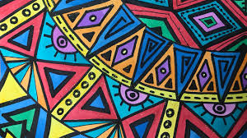
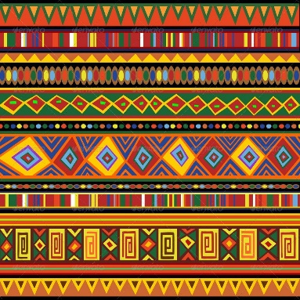

- Name your three primary colours and three secondary colours.
- BONUS: Can you name two or more tertiary colours?
- What colours do you usually associate with African art?
- Which of the formal elements do you think is most important when creating art and why?
- Line
- Tone
- Form
- Colour
- Composition
- Shape
- Pattern
- Texture
- Create an A5 line drawing in the style of African Art.

