****Year 10 History

Work Booklet

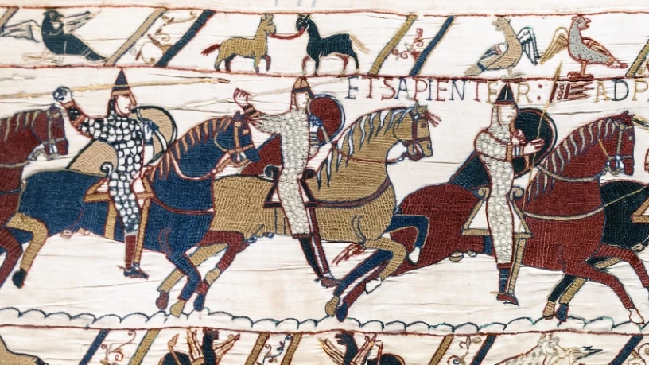Anglo-Saxon and Norman England 1060-1088

Name: _____________________________________

Class: _________________

Teacher: ___________________________________

1. **Anglo-Saxon resistance, 1068 (Page 12)**
2. Who led the rebellion in 1068?

…………………………………………………………………………………………………………………………………………

1. Who joined in with this rebellion?

…………………………………………………………………………………………………………………………………………

1. Complete the mind map below:

Bad government

Castles

Taxes

The loss of lands

Morcar’s Resentment

Edwin’s Resentment

Causes of the Revolt

1. Summarise William’s response to the rebellion

…………………………………………………………………………………………………………………………………………

…………………………………………………………………………………………………………………………………………

…………………………………………………………………………………………………………………………………………

…………………………………………………………………………………………………………………………………………

…………………………………………………………………………………………………………………………………………

……………………………………………………………………………………………………………………………………………………………………………………………………………………………………………………………………………………

…………………………………………………………………………………………………………………………………………

1. What were the consequences of the rebellion?

…………………………………………………………………………………………………………………………………………

…………………………………………………………………………………………………………………………………………

…………………………………………………………………………………………………………………………………………

…………………………………………………………………………………………………………………………………………

…………………………………………………………………………………………………………………………………………

……………………………………………………………………………………………………………………………………………………………………………………………………………………………………………………………………………………

…………………………………………………………………………………………………………………………………………

1. Explain why Odo of Bayeux and William FitzOsbern helped cause the revolt of 1068.

…………………………………………………………………………………………………………………………………………

…………………………………………………………………………………………………………………………………………

…………………………………………………………………………………………………………………………………………

…………………………………………………………………………………………………………………………………………

…………………………………………………………………………………………………………………………………………

……………………………………………………………………………………………………………………………………………………………………………………………………………………………………………………………………………………

…………………………………………………………………………………………………………………………………………

**GCSE STYLE QUESTION:**

**Describe two features of the Anglo-Saxon resistance of 1068 [4]**

Feature 1:

…………………………………………………………………………………………………………………………………………

…………………………………………………………………………………………………………………………………………

…………………………………………………………………………………………………………………………………………

…………………………………………………………………………………………………………………………………………

…………………………………………………………………………………………………………………………………………

Feature 2:

…………………………………………………………………………………………………………………………………………

…………………………………………………………………………………………………………………………………………

…………………………………………………………………………………………………………………………………………

…………………………………………………………………………………………………………………………………………

…………………………………………………………………………………………………………………………………………

|  |
| --- |
| **CMQ:**  Do you think William dealt with the rebellion of 1068 well? Should he have done anything different? What else could he have done to keep control in England an make sure that the people of England followed him?  …………………………………………………………………………………………………………………………………………  …………………………………………………………………………………………………………………………………………  …………………………………………………………………………………………………………………………………………  …………………………………………………………………………………………………………………………………………  …………………………………………………………………………………………………………………………………………  …………………………………………………………………………………………………………………………………………  …………………………………………………………………………………………………………………………………………  …………………………………………………………………………………………………………………………………………  ………………………………………………………………………………………………………………………………………… |

1. **Edgar the Aethling and the rebellions in the North, 1069 (Page 13)**
2. What happened in York in January 1069?

………………………………………………………………………………………………………………………………………………………………………………………………………………………………………………………………………………………………………………………………………………………………………………………………………………………………

1. What happened in York in February 1069?

………………………………………………………………………………………………………………………………………………………………………………………………………………………………………………………………………………………………………………………………………………………………………………………………………………………………

1. Complete the chart of Anglo-Danish attacks on York.

|  |  |  |  |  |
| --- | --- | --- | --- | --- |
| **September 1069** |  |  |  | William’s solutions |
| * King _________ of Denmark sends a large invasion fleet to England. * The Danish invasion force meets up with ___________________ * 21 September 1069: the Anglo-Danish attack on York. 3000 Normans are killed. * The Danes retreat to the Lincolnshire coast. | * Anglo-Saxons in the north begin ________________, sheltered by locals. * New rebellions begin in ______________, Shrewsbury and Chester. * As soon as William’s forces subdue unrest in one ____________, it starts again somewhere else. * The Danes bide their time, protected by Marshland. | 1. Pay the Danes to leave England |
| and |
| 1. The Harrying of the North |

1. Who started the rebellion in Ely?

…………………………………………………………………………………………………………………………………………

1. What did the person in the answer above want to do?

………………………………………………………………………………………………………………………………………………………………………………………………………………………………………………………………………………………………………………………………………………………………………………………………………………………………

1. One outcome of the Anglo-Saxon resistance 1068-71 was that William decided to replace the remaining Anglo-Saxon aristocracy with Normans. Describe one other outcome.

…………………………………………………………………………………………………………………………………………

………………………………………………………………………………………………………………………………………………………………………………………………………………………………………………………………………………………………………………………………………………………………………………………………………………………………………………………………………………………………………………………………………………………………………………………………………………………………………………………………………………………………………………………………………………………………………………………………………………………………………………………………

|  |
| --- |
| **CMQ:**  As a result of Hereward’s rebellion at Ely, William decided that England could not be ruled with consent and that the Anglo-Saxon aristocracy needed to be removed? What could William do to enforce this? Explain your answer.  ……………………………………………………………………………………………………………………………………  ……………………………………………………………………………………………………………………………………  …………………………………………………………………………………………………………………………………  ……………………………………………………………………………………………………………………………………  ……………………………………………………………………………………………………………………………………  ……………………………………………………………………………………………………………………………………  …………………………………………………………………………………………………………………………………  ……………………………………………………………………………………………………………………………………  …………………………………………………………………………………………………………………………………… |

1. **The Harrying of the North (Page 14)**
2. Use the information on page 14 to complete the mind map

Harrying of the North

Long Term Consequences

Immediate Consequences

Features

Reasons

**GCSE STYLE QUESTION:**

‘The main consequence of Anglo-Saxon resistance 1068-70 was an increase in Norman control of England.’ How far do you agree? Explain your answer. **[16 marks]**

You may use the following in your answer:

* The Harrying of the North
* Hereward the Wake

You **must** also use information of your own.

|  |
| --- |
| Exam Tips:   * You should write 3 paragraphs and a conclusion (use the two bullet points to help you with your first two paragraphs) * Use PEEL to structure your paragraphs. * Your conclusion should be strong – how far do you agree with the statement – do you totally agree? Partially agree? Disagree? |

*It can be argued that the main consequence of Anglo-Saxon resistance 1068-70 was an increase in Norman control of England. One reason for this is the Harrying of the North. This was when ………………………………………………………………………………………………………………………………*

*………………………………………………………………………………………………………………………………………………*

*………………………………………………………………………………………………………………………………………………*

*………………………………………………………………………………………………………………………………………………*

*………………………………………………………………………………………………………………………………………………*

*………………………………………………………………………………………………………………………………………………*

*………………………………………………………………………………………………………………………………………………*

*………………………………………………………………………………………………………………………………………………*

*………………………………………………………………………………………………………………………………………………*

*………………………………………………………………………………………………………………………………………………*

*………………………………………………………………………………………………………………………………………………*

*………………………………………………………………………………………………………………………………………………*

*………………………………………………………………………………………………………………………………………………*

*………………………………………………………………………………………………………………………………………………*

*………………………………………………………………………………………………………………………………………………*

*………………………………………………………………………………………………………………………………………………………………………………………………………………………………………………………………………………………………*

*………………………………………………………………………………………………………………………………………………*

*………………………………………………………………………………………………………………………………………………*

*………………………………………………………………………………………………………………………………………………*

*………………………………………………………………………………………………………………………………………………*

*………………………………………………………………………………………………………………………………………………*

*………………………………………………………………………………………………………………………………………………*

*………………………………………………………………………………………………………………………………………………*

*………………………………………………………………………………………………………………………………………………*

*………………………………………………………………………………………………………………………………………………*

*………………………………………………………………………………………………………………………………………………*

*………………………………………………………………………………………………………………………………………………*

*………………………………………………………………………………………………………………………………………………*

*………………………………………………………………………………………………………………………………………………*

*………………………………………………………………………………………………………………………………………………*

*………………………………………………………………………………………………………………………………………………*

*………………………………………………………………………………………………………………………………………………*

*………………………………………………………………………………………………………………………………………………*

*………………………………………………………………………………………………………………………………………………*

*………………………………………………………………………………………………………………………………………………*

*………………………………………………………………………………………………………………………………………………*

*………………………………………………………………………………………………………………………………………………*

*………………………………………………………………………………………………………………………………………………*

*………………………………………………………………………………………………………………………………………………*

*………………………………………………………………………………………………………………………………………………*

*………………………………………………………………………………………………………………………………………………*

*………………………………………………………………………………………………………………………………………………*

*………………………………………………………………………………………………………………………………………………*

*………………………………………………………………………………………………………………………………………………*

*………………………………………………………………………………………………………………………………………………………………………………………………………………………………………………………………………………………………*

*………………………………………………………………………………………………………………………………………………*

*………………………………………………………………………………………………………………………………………………*

*………………………………………………………………………………………………………………………………………………*

*………………………………………………………………………………………………………………………………………………*

*………………………………………………………………………………………………………………………………………………*

*………………………………………………………………………………………………………………………………………………*

*………………………………………………………………………………………………………………………………………………*

*………………………………………………………………………………………………………………………………………………*

*………………………………………………………………………………………………………………………………………………*

*………………………………………………………………………………………………………………………………………………*

*………………………………………………………………………………………………………………………………………………*

*………………………………………………………………………………………………………………………………………………*

*………………………………………………………………………………………………………………………………………………*

*………………………………………………………………………………………………………………………………………………*

*………………………………………………………………………………………………………………………………………………*

*………………………………………………………………………………………………………………………………………………*

*………………………………………………………………………………………………………………………………………………*

*………………………………………………………………………………………………………………………………………………*

*………………………………………………………………………………………………………………………………………………*

*………………………………………………………………………………………………………………………………………………*

*………………………………………………………………………………………………………………………………………………*

*………………………………………………………………………………………………………………………………………………*

*………………………………………………………………………………………………………………………………………………*

*………………………………………………………………………………………………………………………………………………*

*………………………………………………………………………………………………………………………………………………*

*………………………………………………………………………………………………………………………………………………*

*………………………………………………………………………………………………………………………………………………*

*………………………………………………………………………………………………………………………………………………*