STRATEGIC EQUALITY PLAN FOR DEAN TRUST SCHOOLS

Dean Trust Rose Bridge

The Dean Trust
Dean Trust Rose Bridge

Strategic Equality Plan 2019 – 2022

Strategic Equality Plan agreed by Trust Board Governors:

….…………………..……………. ……………………………(Signed by Chair)

………………………………………………………………….Date

Scheme due for review: January 2022

Contents of our Strategic Equality Plan (SEP)

Our distinctive character, values, priorities and aims 5
  - School values
  - Characteristics of our school
  - Mainstreaming equality into policy and practice
  - Setting our equality objectives

Responsibilities 7
  - Governing Body
  - Senior Leadership Team
  - Staff – teaching and non-teaching

Information gathering and Engagement 8
  - Purpose and process
  - Types of information gathered
  - Engagement

Equality Impact Assessment 10

- Objectives and Action Plans 10

- Publication and reporting 11

- Monitor and Review 11

Appendices
App. 1 Regional Equality Objectives

App. 2 School Equality Objectives and Action Plan

- Our Distinctive Character, Priorities and Aims
School values
The following principles underline everything we do
  - A respect for all pupils and their parents/carers
  - A full commitment to professionalism.
  - A well-ordered and caring school community.
The school aims to
    - Help pupils to achieve their full academic potential.
    - Help pupils to acquire knowledge and skills relevant to adult life, employment and leisure in a fast changing world.
    - Help pupils to be literate and numerate.
    - Encourage the principles of common sense and courtesy and to develop a respect for other people and their property.
    - Help and encourage all concerned to maintain the school’s good reputation.
    - Create a happy and stable environment in which learning can take place.
    - Help pupils to develop
- lively, enquiring minds;
- the ability to question and argue rationally;
- the ability to apply themselves to tasks and physical skills.
    - Help pupils to understand the effect of human activities on the environment.
    - Help pupils understand and respect the world in which they live and the interdependence of individuals, groups of people and nations.
    - Help pupils develop sensitivity, empathy, tolerance, self-control, sympathy and an understanding of others.
    - Prepare pupils for future economic roles as producers, consumers and citizens.
    - Help pupils contribute to an industrialised and highly technological society.
    - Help pupils to understand enterprise, wealth creation and entrepreneurial skills.
    - Help pupils to develop an interest in their own good health and physical and mental well-being and acquire the skills to make positive choices and decisions throughout their lives.
    - Increase pupils’ awareness of the wide variety of religious and cultural experiences, beliefs and practices to be found in the world so that they may develop an awareness and understanding of their own beliefs and respect the rights and values of others.
    - Offer pupils equality of opportunity in learning, regardless of gender or special educational needs.
    - Combat racial discrimination and prejudice.

School Values

At the Dean Trust, we are committed to ensuring equality of education and opportunity for all pupils, staff, parents and carers receiving services from the school, irrespective of disability, race, gender, age, sexual orientation, religion or belief, gender reassignment, pregnancy & maternity, marriage and civil partnership. We aim to develop a culture of inclusion and diversity in which all those connected to the school feel proud of their identity and able to participate fully in school life.

The achievement of pupils will be monitored and we will use this data to support pupils, raise standards and ensure inclusive teaching. We will tackle discrimination by the positive promotion of equality, challenging bullying and stereotypes and creating an environment which champions respect for all. At the Dean Trust, we believe that diversity is a strength, which should be respected and celebrated by all those who learn, teach and visit here.

  - Characteristics of our school

Dean Trust Rose Bridge is a secondary school with approximately 700 pupils on roll of ages 11-16. Dean Trust Rose Bridge serves the community of Ince in Wigan, a borough which experiences higher than average levels of economic deprivation. We are in the highest quintile for FSM6 with 56% of the school cohort being eligible for Pupil Premium. The school is in the lowest percentile nationally for ethnic minority pupils, with 93.2% of the cohort being predominantly white British. Our SEND is also in the highest quintile with double the number receiving support than national. The average attainment on entry to the school from KS2 is significantly below the national average, with the majority of year groups indicated as negative sig on Analyse School Performance (ASP). Reading ages on entry are significantly lower than the national average and pupils reaching and exceeding their chronological reading age is a key priority for the school. School leaders and governors across the Trust have been instrumental in raising standards and embedding core values in all key areas of the school and as a result Dean Trust Rose Bridge is now a flourishing, thriving and ambitious community. The school’s reputation is at an all- time high, parental perception has shifted and Dean Trust Rose Bridge Academy is now a local secondary school of choice.

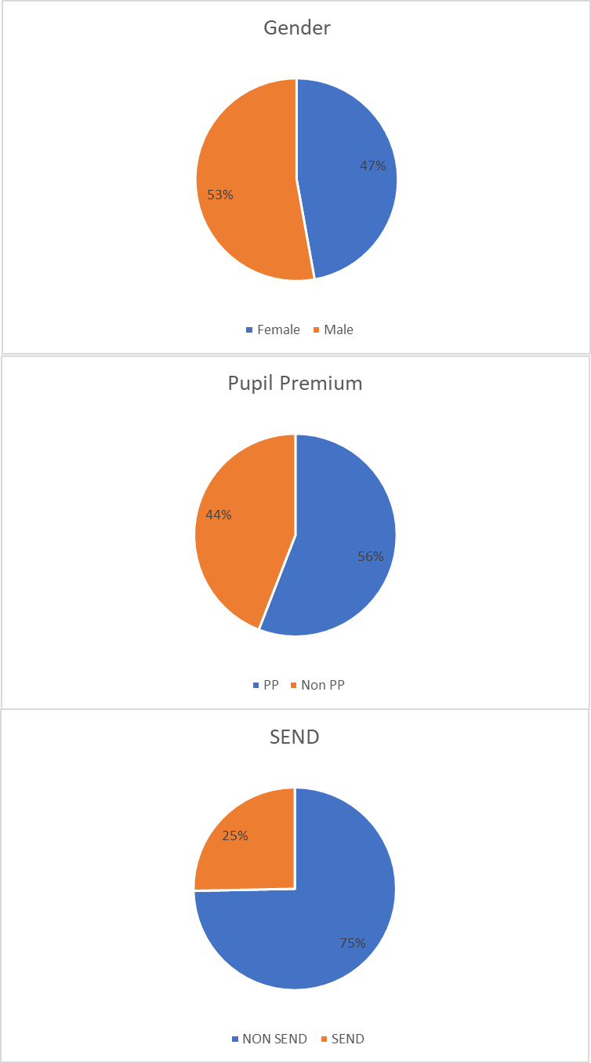
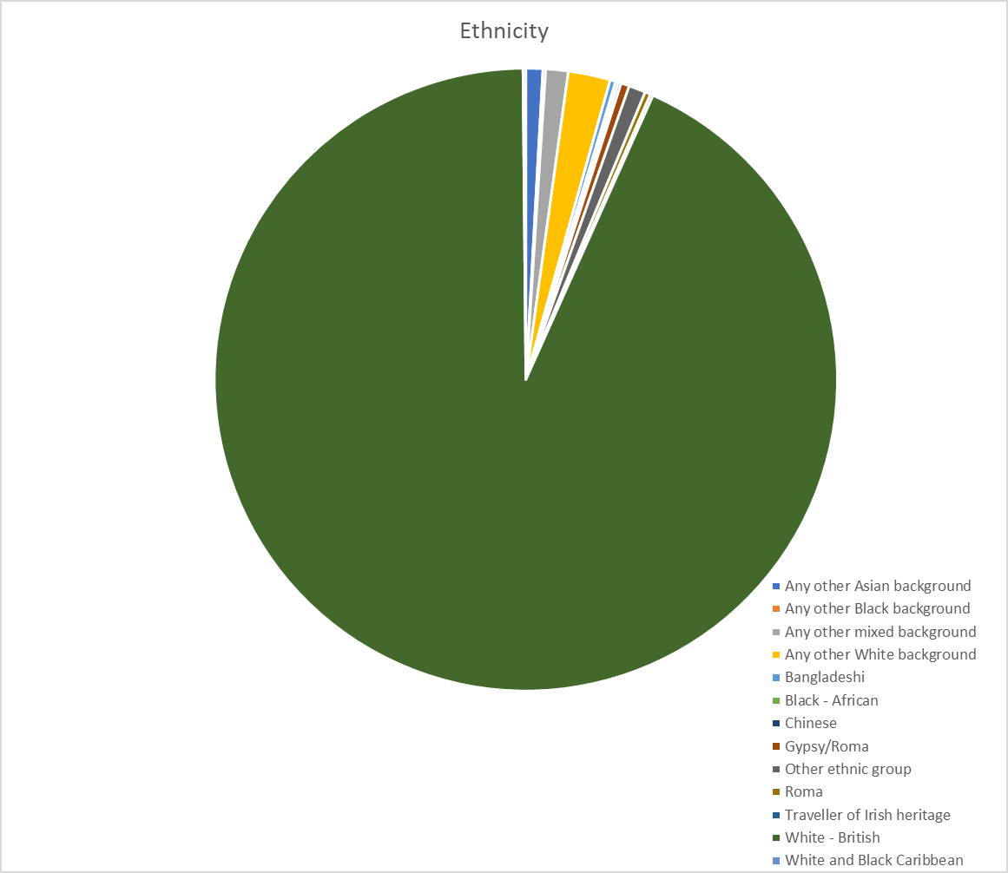

Mainstreaming equality into policy and practice
As well as the specific actions set out beneath this plan, the school operates equality of opportunity in its day to day practice in the following ways.

We aim to provide all our pupils with the opportunity to succeed, and to reach the highest level of personal achievement. To do this, we:
    - use contextual data to improve the ways in which we provide support to individuals and groups of pupils;
    - monitor achievement data according to the various protected characteristics and action any gaps;
    - take account of the achievement of all pupils when planning for future learning and setting challenging targets;
    - ensure equality of access for all pupils and prepare them for life in a diverse society;
    - use materials that reflect the diversity of the school, population and local community in terms of the various protected characteristics, without stereotyping;
    - promote attitudes and values that will challenge racist and other discriminatory behaviour or prejudice;
    - provide opportunities for pupils to appreciate their own culture and celebrate the diversity of other cultures;
    - seek to involve all parents/carers in supporting their child’s education;
    - encouraging classroom and staffroom discussion of equality issues which reflect on social stereotypes, expectations and the impact on learning;
    - including teaching and classroom-based approaches appropriate for the whole school population, which are inclusive and reflective of our pupils

Setting our equality objectives
We recognise our duty and responsibility to establish equality for all learners, staff, other members of the school community and service users regardless of their age, race, gender, disability, gender reassignment, sexual orientation, pregnancy & maternity, religion or belief, marriage and civil partnership as defined within the Equality Act 2010.

The purpose of our Strategic Equality Plan (SEP) is to fulfil the duties to promote equality for people with ‘protected characteristics’, and embed fairness and equality at the heart of our school community and in all aspects of our school plans and policies.
In setting the equality objectives for this school, we will take due regard to the Equality Act general duty:
- Eliminate discrimination, harassment, victimisation and any other conduct that is prohibited under the Act;
- Advance equality of opportunity between persons who share a relevant protected characteristic and persons who do not share it; this means
  - removing or minimising disadvantages suffered by persons who share a relevant protected characteristic that are connected to that characteristic
  - taking steps to meet the needs of persons who share a relevant protected characteristic that are different from the needs of persons who do not share it
  - encouraging persons who share a relevant protected characteristic to participate in public life or in any other activity in which participation by such persons is disproportionately low
- Foster good relations between persons who share a relevant protected characteristic and persons who do not share it

Our SEP and Equality Objectives are set in the light of:
- The regional equality objectives identified in Appendix 1;
- views expressed by stakeholders that have been involved in the development of the scheme;
- issues arising as a result of our analysis of our pupil data, e.g. Gaps in attainment and achievement for the following cohorts
Disadvantaged pupils Male and Female pupils
Special Educational Needs and Disability Pupils

The delivery of our SEP will contribute to all of our actions and commitments to:
- raise standards;
- narrow the attainment and achievement gap in outcomes for children and young people
- improve outcomes as described within the Children and Young People Plan (CYPP);promote community cohesion

Our School Equality Objectives are set out in Section 5 (p.10) and Appendix 2.

Responsibilities

Governing Body
The Trust board and the governing body has set out its commitment to equality and diversity in this plan and it will continue to do all it can to ensure that the school is fully inclusive to pupils and staff, and responsive to their needs based on the various protected characteristics. The governing body:
    - seeks to ensure that people are not discriminated against when applying for jobs at our school;
    - takes all reasonable steps to ensure that the school environment gives access to people with disabilities, and also strives to make communications as inclusive as possible for parents, carers and pupils;
    - ensures that no child or staff member is discriminated against whilst in our school

In order to meet its reporting responsibility, the governing body will report on the progress of the SEP annually, as part of its Annual Report to parents.

Senior Leadership Team (SLT)
The SLT promotes equality and eliminates discrimination by:

    - implementing the school’s SEP, supported by the governing body in doing so;
    - ensuring that all staff are aware of their responsibilities under the Act and are fully informed of our school’s SEP and equality objectives,
    - ensuring that all appointment panels give due regard to this plan, so that no one is discriminated against when it comes to employment or training opportunities;
    - promoting the principle of equal opportunity when developing the curriculum, and promoting respect for other people and equal opportunities to participate in all aspects of school life;
    - treating all incidents of unfair treatment and any incidents of bullying or discrimination, including racist incidents, according to the Trust/ Authority and school policies
    - ensuring that all staff are aware of their role in ensuring equality

Staff – teaching and non-teaching

The school regards equality for all as a responsibility for all. All members of staff contribute to ensuring that our school is a fair, just and cohesive community by:

- ensuring that all pupils are treated fairly, equally and with respect, and will maintain awareness of the school’s SEP;
- striving to provide material that gives positive images based on the protected characteristics and challenges stereotypical images;
- challenging any incidents of prejudice, racism or homophobia, and record any serious incidents as prescribed in the school’s policies, e.g. reporting of racial incidents;
- supporting the work of ancillary or support staff and encourage them to intervene in a positive way against any discriminatory incidents

Information gathering and Engagement

Purpose and process
The collection of information is crucial to supporting us in deciding what actions to take to improve equality and eliminate discrimination within the school community. The information also subsequently helps us to review our performance, so it needs to be detailed enough to enable us to measure how we are delivering on equality duties. The information also helps us to do accurate impact assessment and identify which of the school’s aims have been achieved and what we need to do better.

Engagement is based on the information gained about representation of different groups. We aim to do this as fully as possible while recognising issues of sensitivity in relation to the different protected characteristics. We take particular steps to ensure disabled children and young people, parents and carers are involved as is their entitlement. The reason that this progress is important is to understand the full range of needs of the school community.

Types of information gathered
The wide range of information gathered to support our planning and action to promote equality and eliminate discrimination includes the following:

- an analysis of the responses received from pupils, parents/carers, staff, governors and community groups following the distribution of a questionnaire to determine equality issues. The questions included in the questionnaire do not highlight specific protected characteristics, but seek to obtain stakeholders’ views across the board;
- identification of children and young people, parents, carers, staff and other users of the school representing the different protected characteristics, if possible and appropriate. This helps us develop and monitor the scheme. Comprehensive and sensitive efforts are made to collect accurate information and meet data protection requirements, in addition to our duty to secure accurate information relating to ethnicity and first language;
- pupil attainment and achievement data relating to different groups;
- children and young people’s views actively sought and incorporated in a way that values their contribution;
- information about how different groups access the whole curriculum and how they make choices between subject options;
- sports and activities choices of all groups;
- uptake of enrichment activities by group;
- exclusions data analysed by group;
- records of bullying and harassment on the grounds of any equality issue;
- data on the recruitment, development and retention of employees;
- outcomes of activities promoting community engagement and community cohesion;
- outcomes of actions taken to secure the involvement of parents and others who have been identified as difficult to engage;

Engagement
The school involves stakeholders including children and young people, staff, parents/carers, governors and other users of the school in relation to all equalities duties. We take into account the preferred means of communication for those with whom we are consulting e.g. translated materials or interpretation facilities for disabled people or those for whom English is an additional language or are newly arrived in this country.

The views of stakeholders and other equalities related groups are genuinely taken into account when we set priorities.
Support from the Trust Board and Governing Body Parent questionnaires and feedback
Pupil voice activities and Pupil Parliament feedback Involvement with Community groups
Work with our local Primary schools e.g. supporting and sponsoring events and offering Primary engagement/opportunities to work with DEAN TRUST ROSE BRIDGE on projects such as the current English, mathematics, MFL projects
Representation at SEND forums within the local community Representation at Looked After Children forums
Working closely with Wigan LA on attendance support/admissions support and guidance

Equality Impact Assessment
Impact assessment refers to the review of all current and proposed plans and policies in order to help us act to promote equality and to ensure no person is disadvantaged by school activities through discrimination. Impact assessments are an on-going process to ensure that the school’s plans and policies are developed in an increasingly inclusive and equitable way.

As part of this school’s compliance of the specific duties of the Act, we will continue to undertake impact assessment of all new policies and plans prior to them being implemented. Similarly, we will impact assess our existing policies and plans whenever they are reviewed. As such, impact assessments are incorporated into the school’s planned review and revision of every policy.

Where impact assessments have been done, they will influence changes to policy and the review of the SEP itself.

Objectives and Action Plans

Our chosen Equality Objectives are
1.Ensuring that our gender gap in all aspects of school life are minimal 2.Working to reduce gaps for disadvantaged groups within our school for achievement, achievement and attendance.
- Ensuring that all pupils irrespective of their needs have full access to all areas of school life
- Teaching SMSC and British Values throughout the curriculum

We have action plans covering all relevant protected characteristics (Appendix 2). These describe how we are taking action to fulfil both the general and specific duties.

Our action plans are cross referenced with the School Improvement Plan which ensures that they are checked, monitored and evaluated systematically.

The action plans show:
- objectives and specific actions;
- expected impact and indicators of achievement (success criteria);
- clear timescales;
- who has lead responsibility;
- resource implications;
- specified dates for impact assessment and review.

The school evaluates the effectiveness of the SEP on a regular basis, through the governing body and when the school is inspected.

Publication and reporting
The school provides a copy of its SEP and its action plan to meet its equality objectives in a range of formats and actively makes it available to parents/carers and others, including those identified as difficult to engage. The school prospectus includes a reference to the SEP and the values underpinning it.

The school reports annually on the progress made on the action plans and the impact of the SEP itself on school ethos and practice within the school. This is undertaken as part of the Governors’ Annual Report.

All data collected is used solely for the purpose of analysing trends by protected characteristic in performance, take -up and satisfaction with services offered by the Trust, school or local authority. Such information is stored separately from personal information which identifies the individual. In order to protect the identities of individuals when trend information is published no counts containing less than 5 individuals will be published.

Monitor and Review
As part of our responsibility to monitor the SEP, we commit to:
- revisiting and analysing the information and data used to identify priorities for the SEP and action plans. This incorporates use of the overview of outcomes;

- using the impact assessments to ensure that actions taken have a positive impact across all protected characteristics, that the promotion of equality is at the heart of school planning and that discrimination is being eliminated effectively.

The review of the SEP informs its revision, the setting of new priorities and action plans. This process continues to:
- involve the participation of a full range of stakeholders;
- be evidenced based - using information and data that the school has gathered and analysed;
- use the evidence to do accurate impact assessments which inform priorities.

We will undertake a full review of our SEP by September 2021.

The Dean Trust Schools
Strategic Equality Plan 2019 – 2022
Appendices
App. 1
Regional Equality Objectives
App. 2 School Equality Objectives and Action Plan App. 3 Current school Access Plan

APPENDIX 1

Regional Equality Objectives North West
- Reduce Gaps in attainment between Boys and Girls and between other protected groups as identified in local data National research indicates inequalities in the levels of attainment between genders, ethnicities and between disabled people and non- disabled people. Boys, black, Bangladeshi and Pakistani pupils and disabled children all perform poorly on average compared to other groups.

Implement Government Bullying Guidance and reduce Identity based bullying in schools
Examples include 22% of year 6 pupils had been ‘bullied in a homophobic way’; 7% of year 7 pupils had been ‘bullied in some way due to learning difficulties’ and 3% of year 10 pupils had been ‘bullied in some way due to race or ethnic origin’.

Reduce gaps in levels of attendance between different protected groups as identified in local data
Work is currently underway to improve data analysis which can identify differences in attendance trends between groups of pupils with different protected characteristics. Several reports have been commissioned nationally which examine attendance of Gypsy Traveller and Irish Traveller children. Each found that attendance was lower among these children.

Reduce the number of NEETs
The North West has a higher proportion of people who were not in education, employment or training (NEET) among the 16-24 year old group within England. Being NEET is a major disadvantage to young people.

- Improve access to information and physical access to schools and other learning settings for pupils, parents and staff. Headteachers and Governors need to be confident that all pupils can reasonably access services and are not unjustifiably disadvantaged by having any of the protected characteristics. Schools already have Disability Access Plans in place. However, schools and local authorities through the public sector equality duties need, to cater for the needs of all protected groups so the scope is wider than Disability Access Plans.

Raise awareness of equality and diversity issues among Pupils, Staff and Governors.
None statutory guidance on the Public Sector Equality Duties states that all Schools must make appropriate arrangements to promote knowledge and understanding of the general and specific duties amongst its employees.’ In the school context we wish to extend this to include pupils and Governors. An example of this is the may be the Channel – Safeguarding Vulnerable People from Being Drawn into Terrorism for staff.

The Dean Trust Schools

Strategic Equality Plan 2019 – 2022 Equality Objectives and Action Plan

Equality Objective 1.
To reduce GCSE performance gaps for key cohort groups to match national other
Our Research:
Significant gaps between the performance of disadvantaged pupils at the school to national other Significant internal gaps in performance of Higher Attaining Pupils at the school to national other
Information from Engagement:
New appointment of senior member of staff with responsibility of PP funding allocation. A strategic PP plan is in place to ensure the significant amount of funding the school receives directly impacts on the performance and experiences of PP pupils. Pupils eligible for PP funding are involved in all aspects of our school community: leadership, enrichment & rewards.
Data Development:
Audit of previous PP position completed; audit of previous PP review taken place; Pupil Premium monitoring focus forms part of Middle Leadership development; analysis of assessment data at each collection; frequent pupil and parent voice sought.
This objective will be judged to be successful if…
- The performance gap between disadvantaged pupils and the non-disadvantaged pupils diminishes.
Actions:
 | Description | Responsibility | Start date | End date
1.1 | Monitor the impact of PP funding in all key areas | SW | May 19 | September 19
1.2 | Collect and analyse data at each assessment window for PP | SW, SL & SJ | July 19 | September 19
1.3 | External PP review to be undertaken and actions implemented. | SW & BB | September 19 | September 20

Equality Objective 2.
To improve the attendance of PP students to match national average.
Our Research:
Dean Trust Rose Bridge is slightly below the national average for attendance; PP pupils’ attendance is below the national average.
Information from Engagement:
Attendance staff support team in place; attendance of PP pupils a target on the School Improvement Plan; uniform provided for all pupils to remove this as potential barrier; rewards system in place for good/improved attendance; lates policy in place to support improvement in punctuality.
Data Development:
Data gathered on a weekly basis following usual protocols. Impact measured each half term. Formal action taken if no improvement.
This objective will be judged to be successful if…
• PP attendance increases to 96% by July 2020
Actions:
 | Description | Responsibility | Start date | End date
1.1 | Appointment of Attendance Team to be responsible for promoting the attendance of all pupils, with particular emphasis upon PP pupils. | PP, LV & Attendance Team | September 19 | November 19
1.2 | Home visits to all PP poor attenders | Attendance & Year Teams | September 19 | July 20
1.3 | Incentives and rewards continued for PP pupils | LV & Year Teams | September 19 | July 20

Equality Objective 3.
Ensure all pupils access further education, training or employment when they leave school
Our Research:
2019 NEET figures were 3% despite 100% of pupils having an offer from either Education, Employment or Training when they left school.

Information from Engagement:
Inclusion and pastoral teams support pupils with poor attendance and lack of aspirations; Careers Information, Advice and Guidance is a key focus for the school and all pupils have access to it; Senior Leader takes overall responsibility for delivering careers provision; audit of careers provision taken place and best practice ascertained across the Trust.
Data Development:
Attendance/progress data will be updated and reviewed constantly; all pupils to have careers meetings in Year 9, 10, 11; parental meetings set up with vulnerable pupils; careers provision included in all parental evenings.
This objective will be judged to be successful if…

- NEET figure is 0%.
Actions:
 | Description | Responsibility | Start date | End date
1.1 | Possible NEET pupils identified | Careers Team | September 19 | December 19
1.2 | List of parents/college support links | EG & Careers Team | September 19 | ongoing
1.3 | Range of opportunities for pupils to access high quality careers provision | EG, HS & Careers Team | September 19 | December 20

