7th June 2019

Dear Parent/Carer,
For those of you in receipt of certain benefits, or where your family’s joint income is below a certain threshold, there is the opportunity to apply for your child to obtain Free School Meals (see criteria attached).
By completing and returning the attached form to us, we will send this off to the Local Authority who will check your eligibility and subsequently advise us if your child is eligible to receive a free school meal.
As well as your child being able to receive a tasty and nutritious school meal each day for free, Dean Trust Rose Bridge will then also be able to claim for additional Pupil Premium funding which would be used to further support your child across the curriculum and school.
If you would like further information about this, please do not hesitate to contact me on the number below to discuss this matter further. Alternatively, please ring the school office to arrange a meeting or phone call at a mutually convenient time. Anything discussed will be treated in the strictest confidence.
If you, or your spouse, is a member of the Armed Forces, there is also the possibility to claim additional money to further support the development of your child. If this applies to you, please contact the school directly to discuss eligibility.
Yours faithfully,

Mr S Walsh
Assistant Headteacher

What are the qualifying benefits?
You will be entitled to apply for free school meals and/or pupil premium for your child if you or your partner receive one or more of the following benefits:
- Universal Credit (see information on new eligibility criteria below)
- Income Support
- Income-based Jobseeker's Allowance
- Income-related Employment and Support Allowance
- The guaranteed part of State Pension Credit
- Support under part 6 of the Immigration and Asylum Act 1999
- Child Tax Credit (providing you are not entitled to Working Tax Credit and have an annual gross income of no more than £16,190, as assessed by the Inland Revenue)
- Working Tax Credit run-on (paid 4 weeks after you stop qualifying for Working Tax Credit)
New eligibility criteria - Universal Credit
From 1st April 2018, the Department for Education made amendments to the eligibility criteria for free school meals to reflect the roll out of Universal Credit full service.
From this date onwards your child will only be eligible for free schools meals under Universal Credit if you and your partner have net earned income of less than £7,400 per year (assessed from up to three of your most recent assessment periods). The Universal Credit rollout is currently expected to be completed by March 2022.
However in the meantime, transitional protections will be implemented for those children who might otherwise lose free school meals following the update to the eligibility criteria.
The transitional protections will be awarded as follows:
Any child who is in receipt of free school meals BEFORE 1 April 2018, will continue to receive free school meals whilst Universal Credit is rolled out (until March 2022) regardless of any changes in you or your partners income
Any child who gains eligibility for free school meals AFTER 1 April 2018 will continue to receive free school meals whilst Universal Credit is rolled out (until March 2022) regardless of any changes in you or your partners income
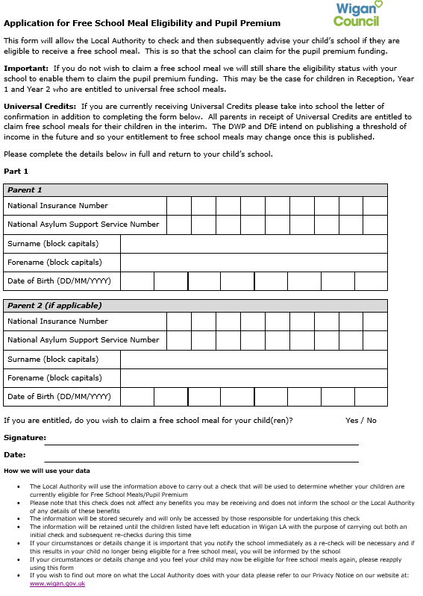
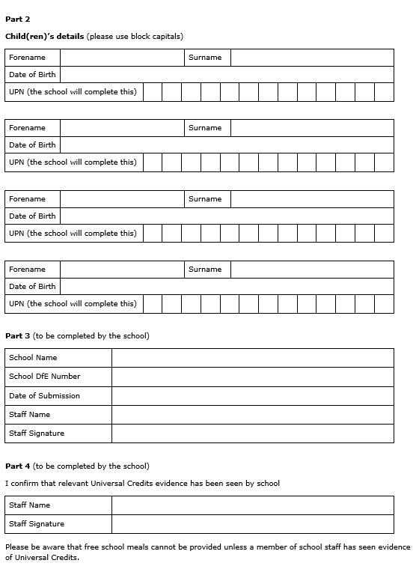
Once Universal Credit is fully rolled out any existing children who no longer meet the eligibility criteria at that point will continue to receive free school meals until the end of their current phase of education, ie primary or secondary.

